# expense manager

##### Task 4.3

Having watched how Ecom project’s models were designed, now it's time to put your imagination to test.

Following is the description of an “Expense Manager” app :

* Expense manager is an app to manage personal expenses (& income)
* User can add/edit/delete transactions
* Transactions can then be viewed filtered according to month

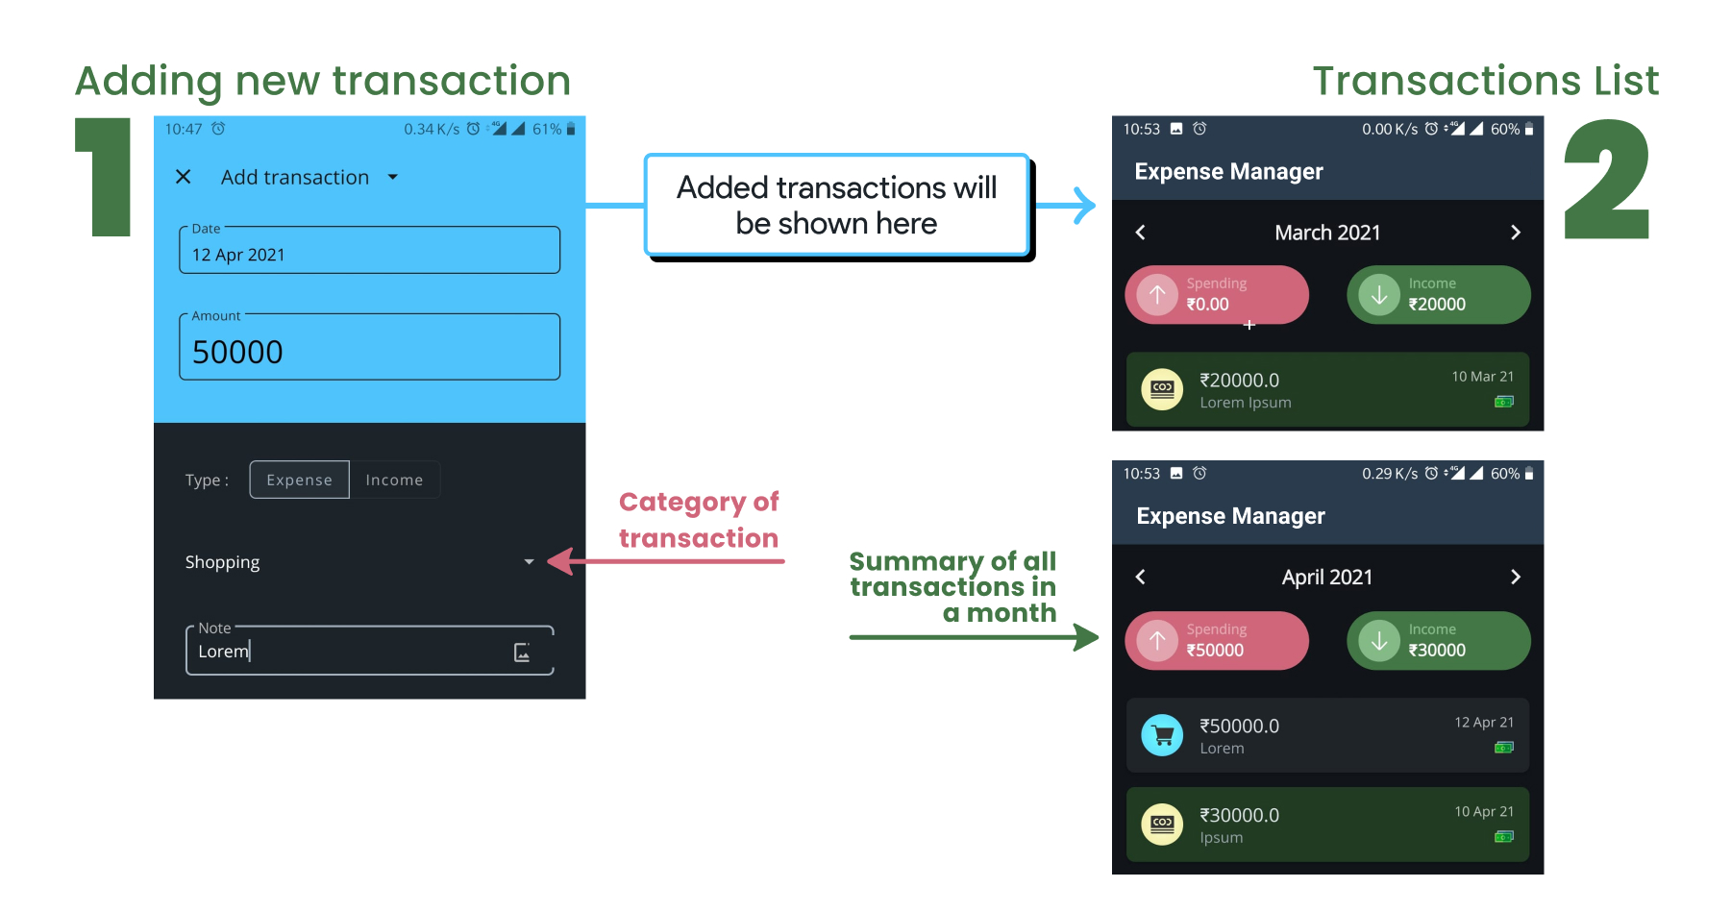

Use your imagination and write model classes for this app. Then, test them in your main class.

* Try to write efficient code
* Learn how to save dates in Java (You will get 3 ints dd, MM & yy as input for date)
* Learn how to format dates
* Do this in a separate project named “Expense Manager”
* Write menu driven program for this where
  + Transactions can be added / edited / removed
  + A month can be picked and it’s transactions & summary should be displayed
* Once done, push it to GitHub and acknowledge in GCR